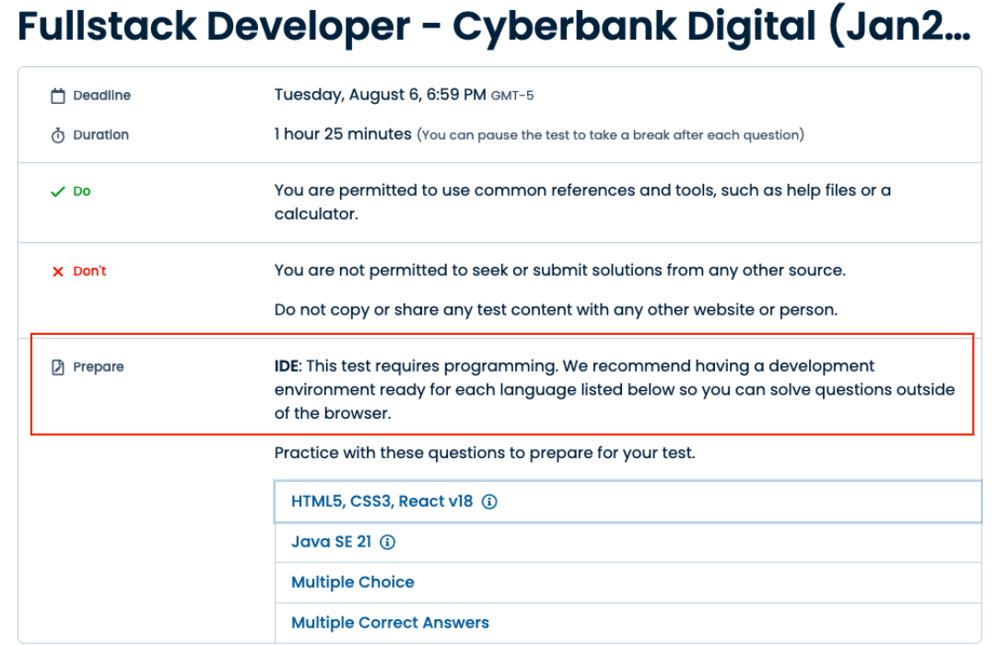

**PREGUNTA 1- JAVA**

**Chemical Machine**

Java

Conditions

Lists

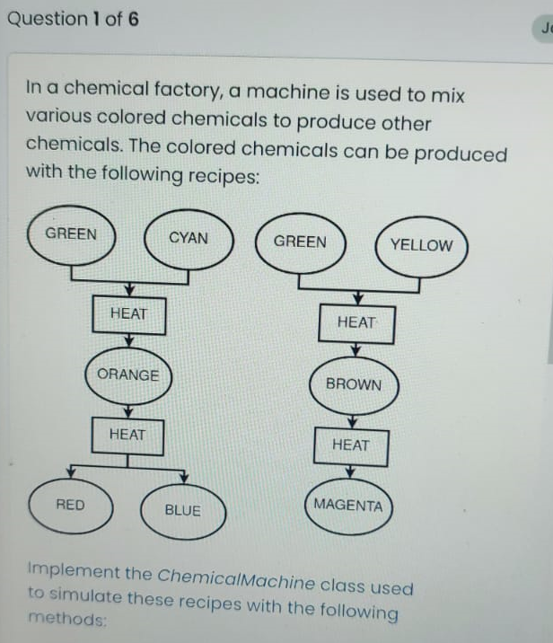

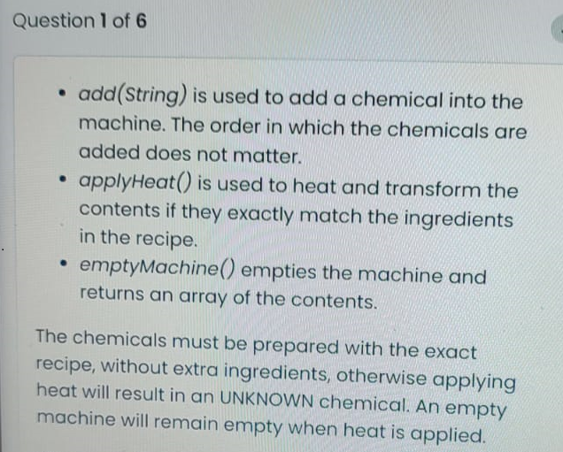

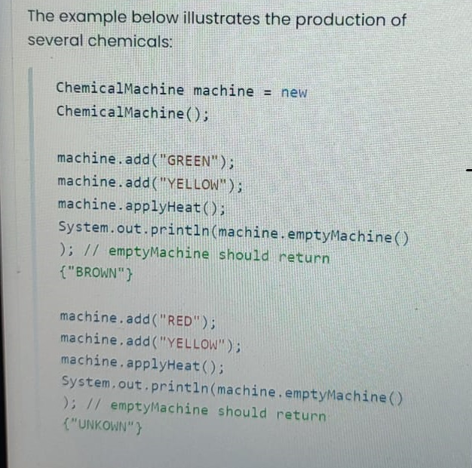

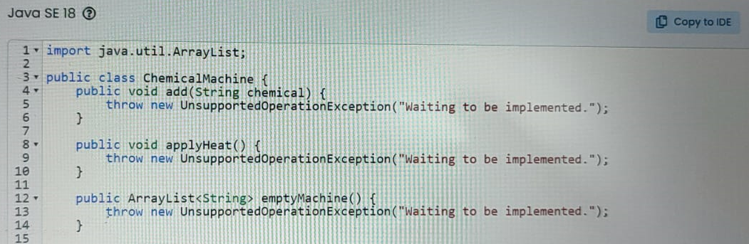

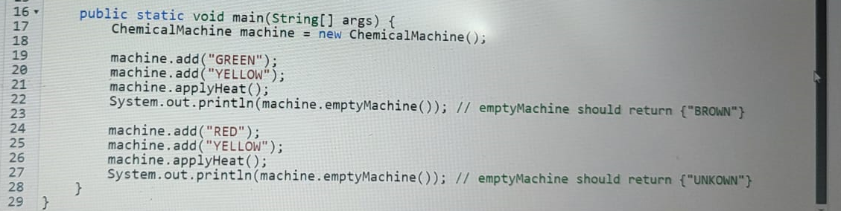



import java.util.ArrayList;

import java.util.Arrays;

import java.util.HashMap;

import java.util.HashSet;

import java.util.Map;

import java.util.Set;

public class ChemicalMachine {

    private ArrayList<String> chemicals = new ArrayList<>();

    private Map<Set<String>, String> recipes = new HashMap<>();

    public ChemicalMachine() {

        // Initialize recipes based on the input images

        recipes.put(new HashSet<>(Arrays.asList("GREEN", "CYAN")), "ORANGE");

        recipes.put(new HashSet<>(Arrays.asList("GREEN", "YELLOW")), "BROWN");

        recipes.put(new HashSet<>(Arrays.asList("ORANGE")), "RED");

        recipes.put(new HashSet<>(Arrays.asList("BROWN")), "MAGENTA");

    }

    public void add(String chemical) {

        chemicals.add(chemical);

    }

    public void applyHeat() {

        // Find if the current chemicals match a recipe

        Set<String> currentSet = new HashSet<>(chemicals);

        if (recipes.containsKey(currentSet)) {

            chemicals.clear();

            chemicals.add(recipes.get(currentSet));

        } else {

            // If the combination is not a valid recipe, produce UNKNOWN

            chemicals.clear();

            if (!currentSet.isEmpty()) {

                chemicals.add("UNKNOWN");

            }

        }

    }

    public ArrayList<String> emptyMachine() {

        ArrayList<String> result = new ArrayList<>(chemicals);

        chemicals.clear();

        return result;

    }

    public static void main(String[] args) {

        ChemicalMachine machine = new ChemicalMachine();

        machine.add("GREEN");

        machine.add("YELLOW");

        machine.applyHeat();

        System.out.println(machine.emptyMachine()); // Should print [BROWN]

        machine.add("RED");

        machine.add("YELLOW");

        machine.applyHeat();

        System.out.println(machine.emptyMachine()); // Should print [UNKNOWN]

    }

}

**PREGUNTA 2 – SPRING**

**Auto Configuration**

Java Spring

Configuration

Spring Boot

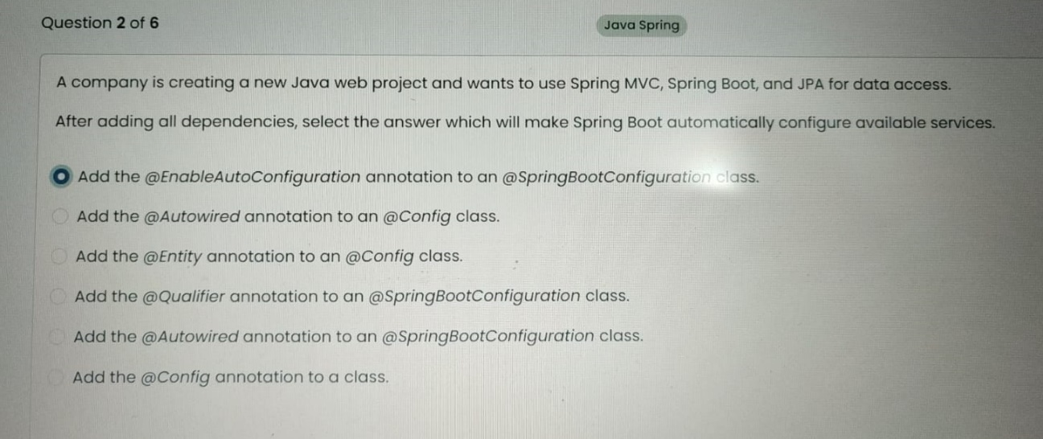

**Add the @EnableAutoConfiguration annotation to an @SpringBootConfiguration class.**

La anotación @SpringBootApplication en Spring Boot ya incluye @EnableAutoConfiguration junto con @ComponentScan y @SpringBootConfiguration. Por lo tanto, al usar @SpringBootApplication, no es necesario agregar explícitamente @EnableAutoConfiguration a una clase @SpringBootConfiguration, ya que esto sería redundante.

En el contexto de la pregunta que has mostrado, sin embargo, si se trata de una pregunta de prueba o un examen y están preguntando específicamente qué anotación activa la autoconfiguración, la respuesta es @EnableAutoConfiguration. Pero en la práctica real al desarrollar una aplicación Spring Boot, simplemente usarías @SpringBootApplication en tu clase principal y eso cubriría la necesidad de autoconfiguración.

**PREGUNTA 3 – React – ReactHooks Reducer Hook**

**Simple Calculator**

React

React Hooks

Reducer Hook

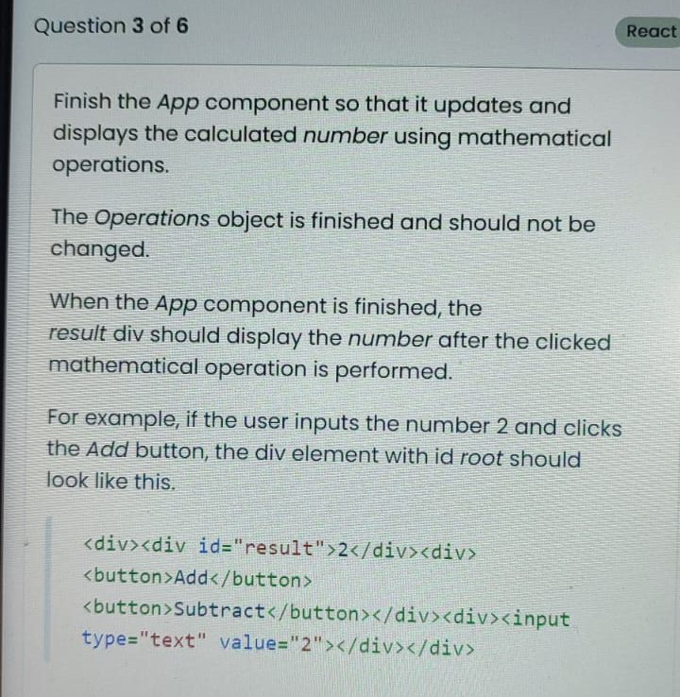

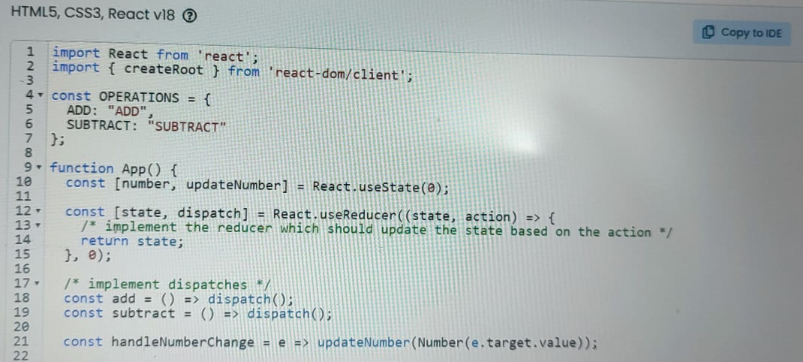

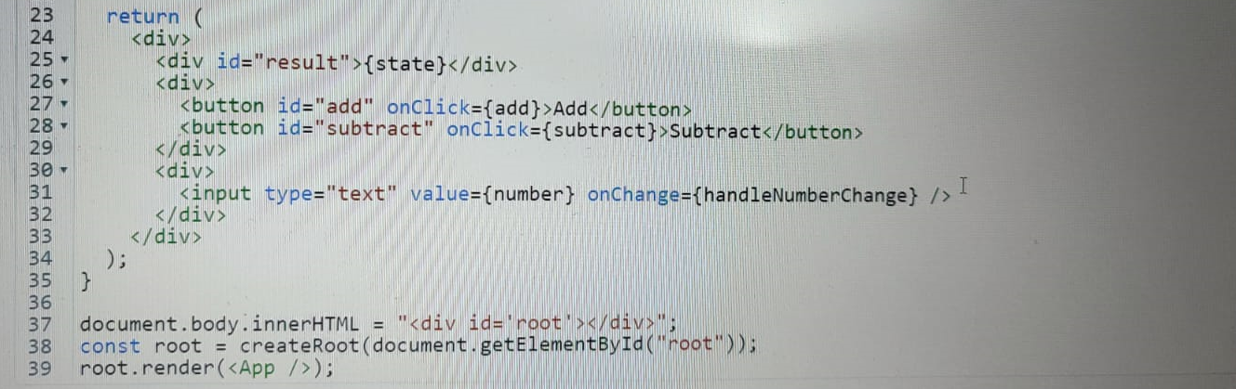

|  |
| --- |
| import React from 'react';  import { createRoot } from 'react-dom/client';  const OPERATIONS = {  ADD: "ADD",  SUBTRACT: "SUBTRACT"  };  function App() {  const [number, updateNumber] = React.useState(0);  const [state, dispatch] = React.useReducer((state, action) => {  switch( action.type ) {    case 'ADD':  return state + action.payload;    case 'SUBTRACT':  return state - action.payload;    default:  return state;  }  },0)  /* implement dispatches */  const add = () => dispatch( { type: OPERATIONS.ADD, payload:number } );  const subtract = () => dispatch( { type: OPERATIONS.SUBTRACT, payload:number } );  const handleNumberChange = e => updateNumber(Number(e.target.value));  return (  <div>  <div id="result">{state}</div>  <div>  <button id="add" onClick={add}>Add</button>    <button id="subtract" onClick={subtract}>Subtract</button>  </div>  <div>  <input type="text" value={number} onChange={handleNumberChange} />  </div>  </div>  );  }  document.body.innerHTML = "<div id='root'></div>";  const root = createRoot(document.getElementById("root"));  root.render(<App />);  export default App; |

**PREGUNTA 4 – React**

**Player Status**

React

Effect Hook

React Hooks

State Hook

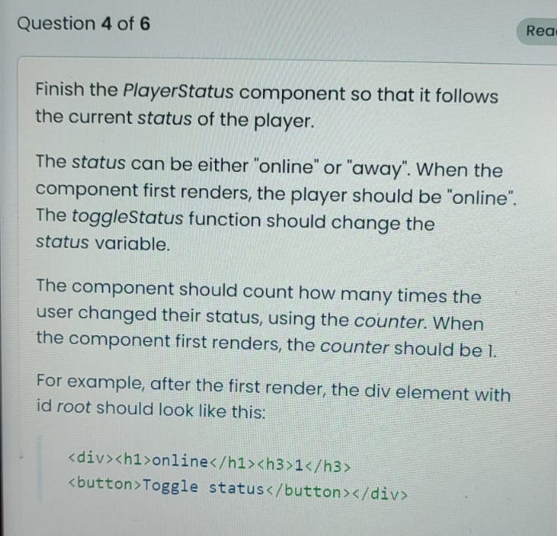

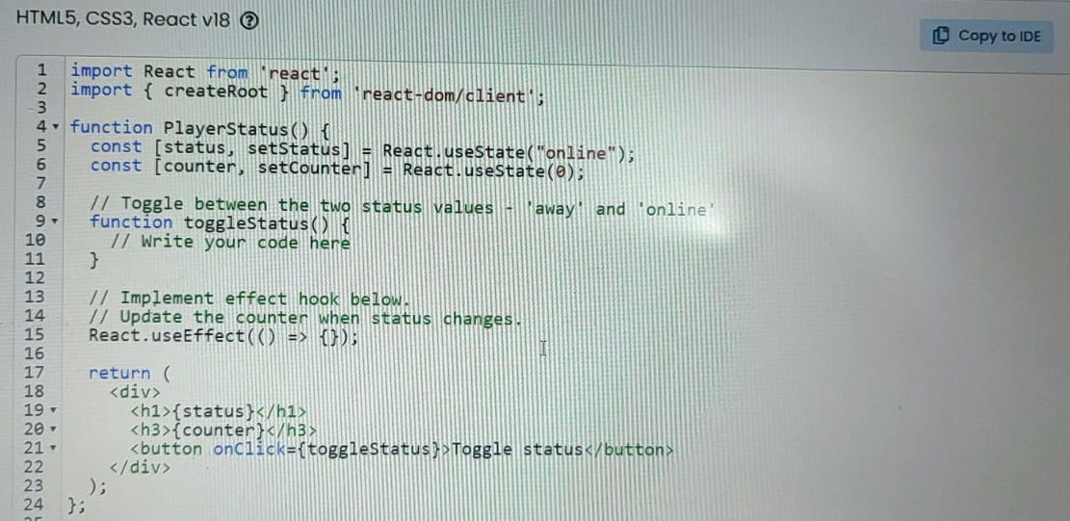

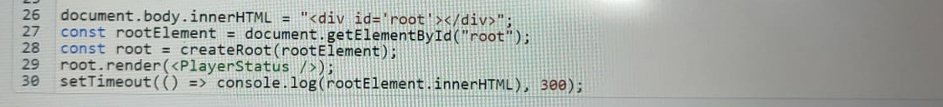

import React from 'react';

import { createRoot } from 'react-dom/client';

function PlayerStatus() {

  const [status, setStatus] = React.useState("online");

  const [counter, setCounter] = React.useState(0);

  // Toggle between the two status values 'away' and 'online'

  function toggleStatus() {

    setStatus(currentStatus => currentStatus === "online" ? "away" : "online");

  }

  // Implement effect hook below

  // Update the counter when status changes

  React.useEffect(() => {

    setCounter(counter => counter + 1);

  }, [status]); // Only re-run the effect if status changes

  return (

    <div>

      <h1>{status}</h1>

      <h3>{counter}</h3>

      <button onClick={toggleStatus}>Toggle status</button>

    </div>

  );

}

// Assuming we want to mount this component into an existing <div id="root"></div> in the HTML

const rootElement = document.getElementById("root");

const root = createRoot(rootElement);

root.render(<PlayerStatus />);

**PREGUNTA 5 – React**

**ProductSearch**

React

Effect Hook

Hooks

State Hook

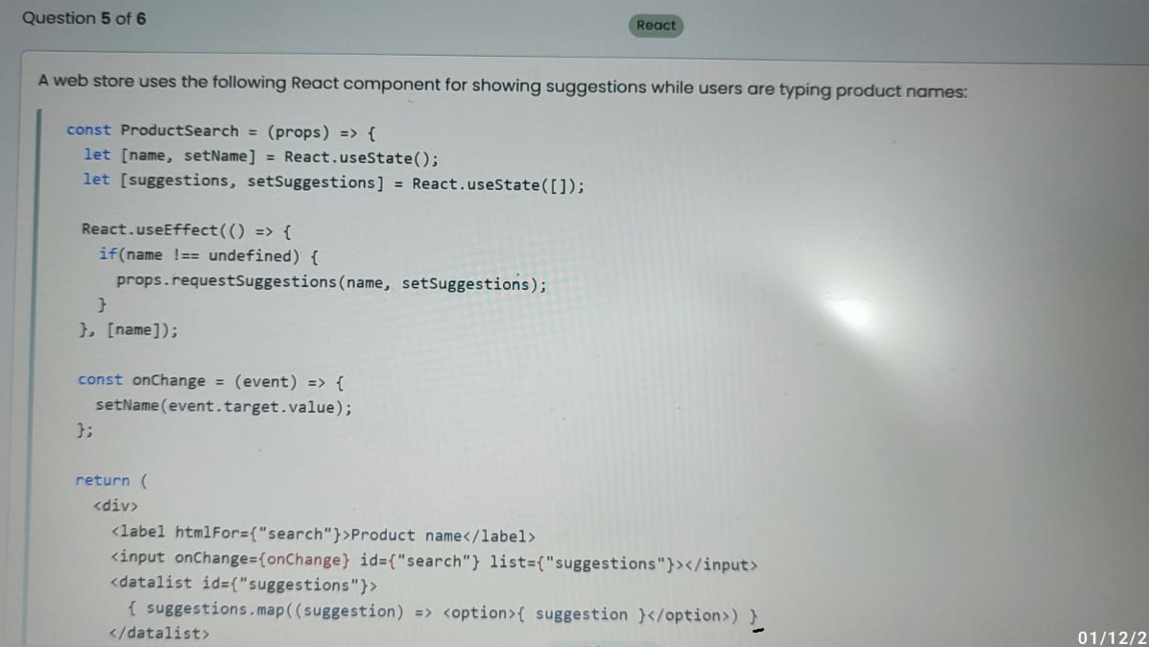



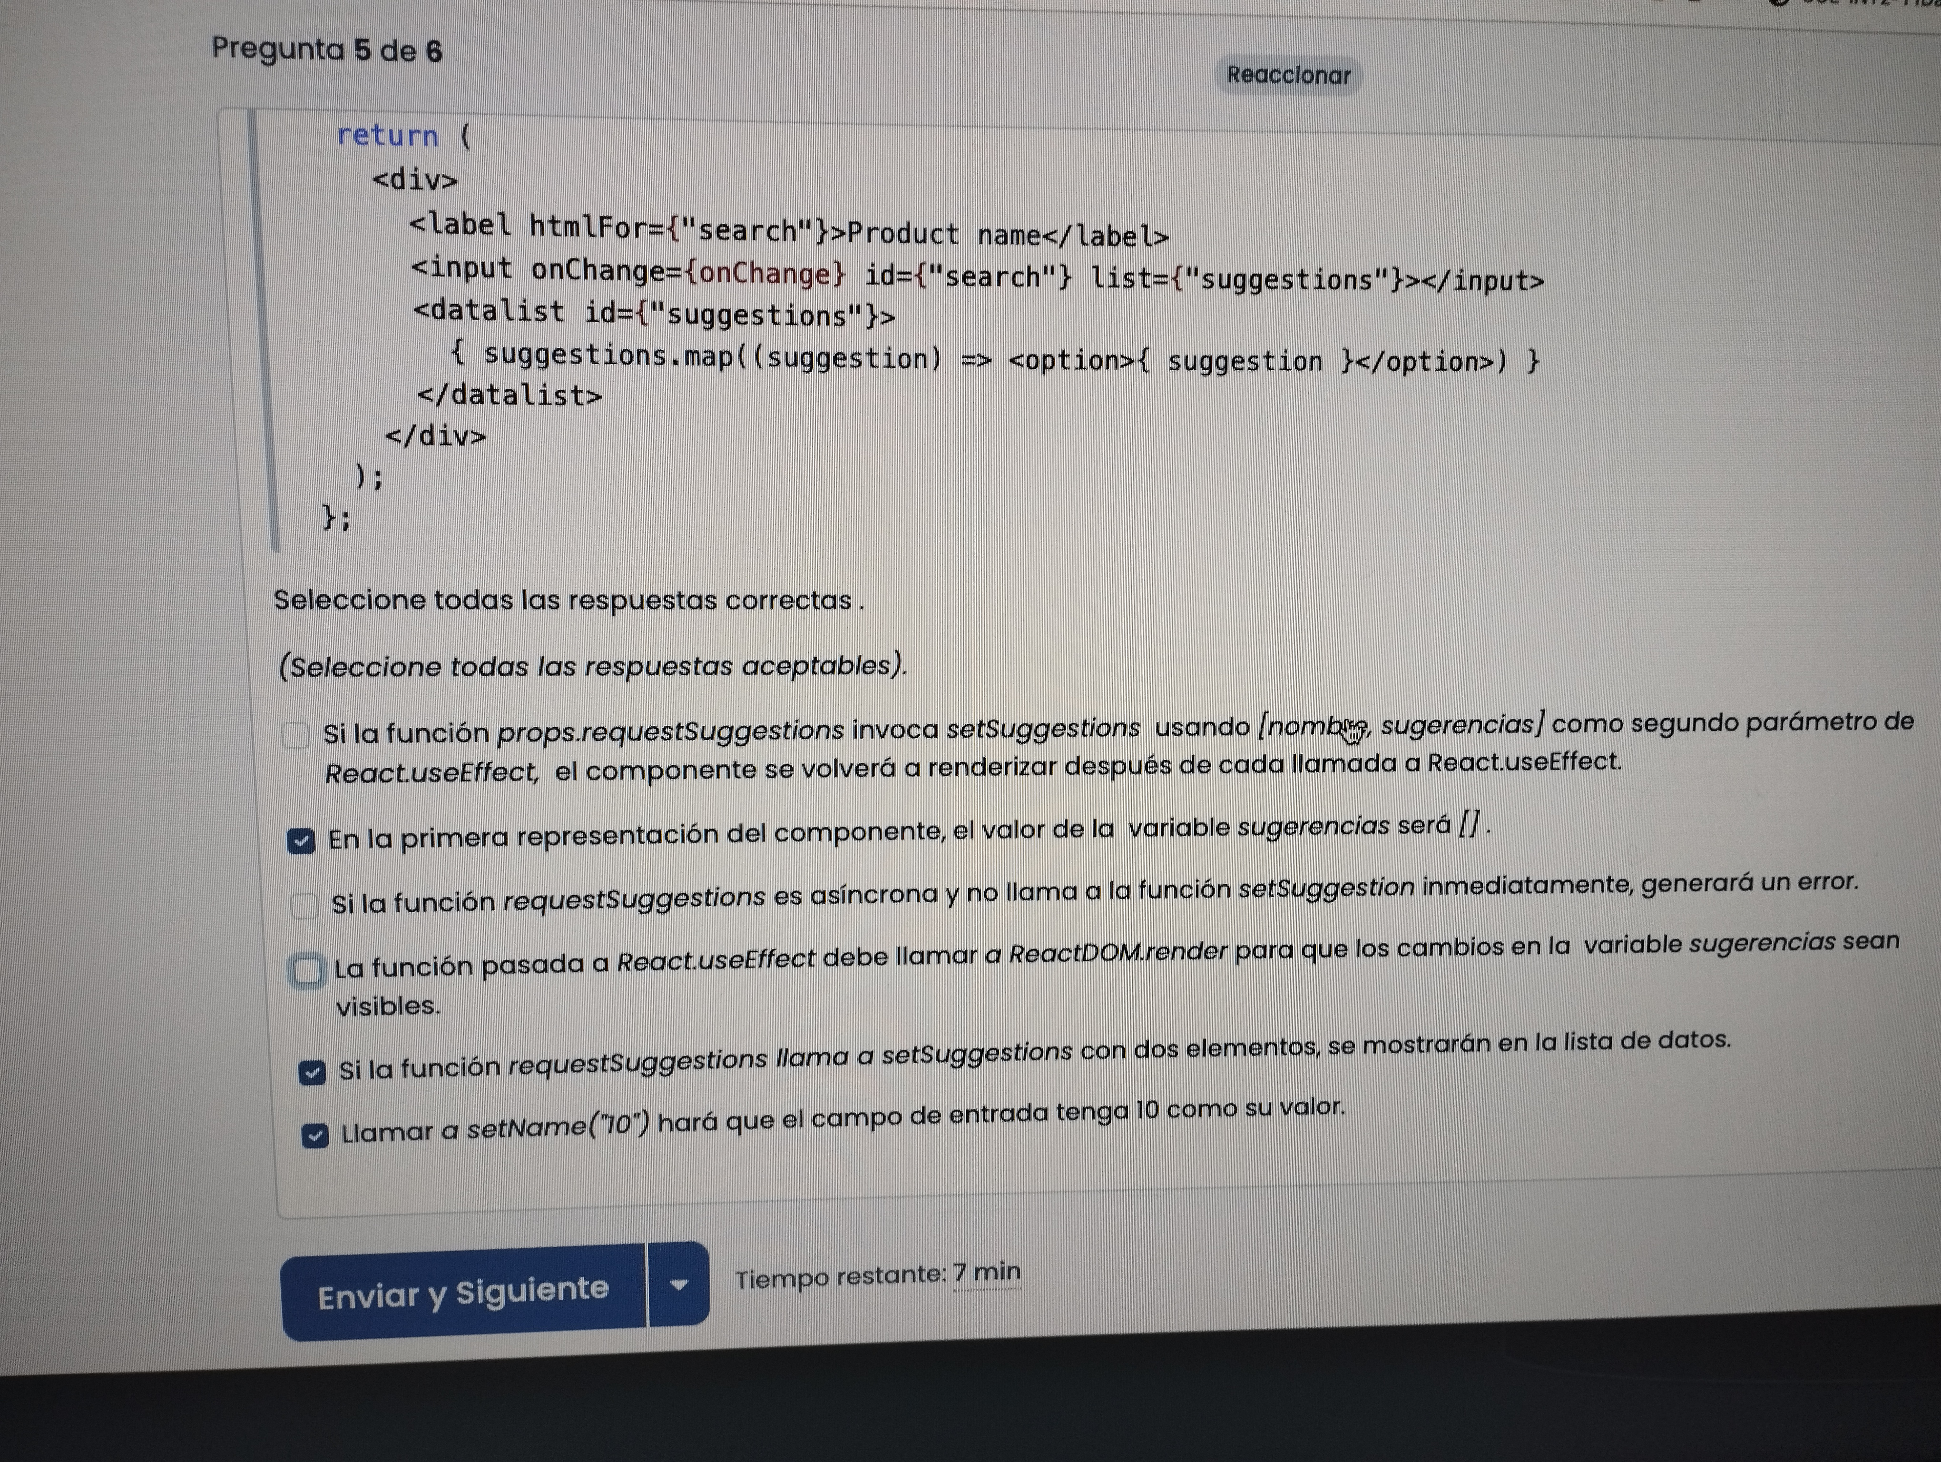

**PREGUNTA 6 – React- Redux**

**MusicPlayList**

Redux Toolkit

Redux Actions

Redux Middleware Personalizados (Redux Toolkit viene con Middleware thunk por defecto)

Redux Reducer

Redux Store

